W5-S2 PRACTICE
CSS GRID LAYOUT

 At the end of this practice, you should be able to…
- Identify the best CSS grid approach in different use cases
- From mockups to CSS grid layout

 How to work?
- Download the start code from the LMS
- Open the folder in VS Code

How to submit?
- Push your final code on your GitHub repository
- Then attach the GitHub path to the MS Team assignment and turn it in

 Are you lost?
You can read the following documentation to be ready for this practice:
- Guide - WC3 School
- Read our amazing book!
- Learn CSS Grid in 20 minutes !
- Check the Grid handout!

EXERCISE 1: The Basics!
 Start code is provided for this exercise!

Using grid layout, build the layout pictured below.
We want a gap of 20px between each item (horizontally and vertically)

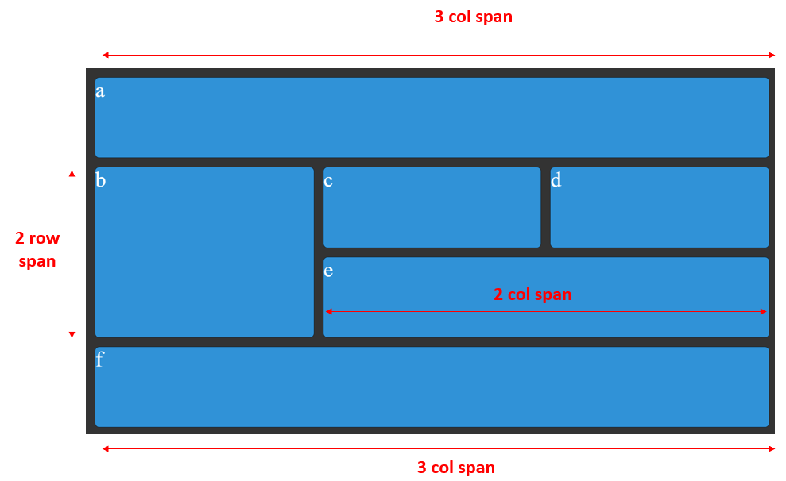

 Are you lost?
TIP 1 - Here are the CSS properties involved in this exercise:
- grid-template-columns
- grid-template-rows
- grid-column
- grid-row
- display
- gap

EXERCISE 2: Nested Grids!
 Start code is provided for this exercise!

Using 2 grid layouts, build the layout pictured below.
- 1 grid to layout the card container
- 1 grid to layout the card

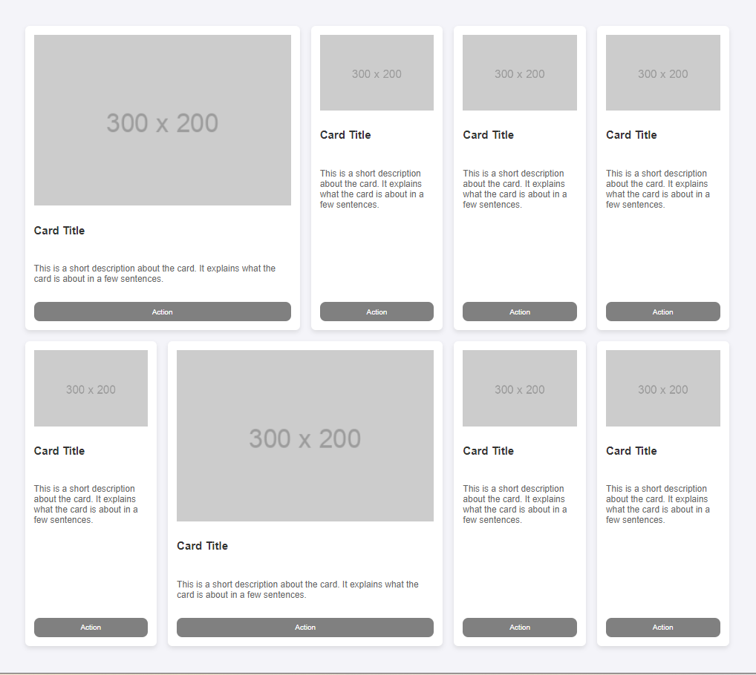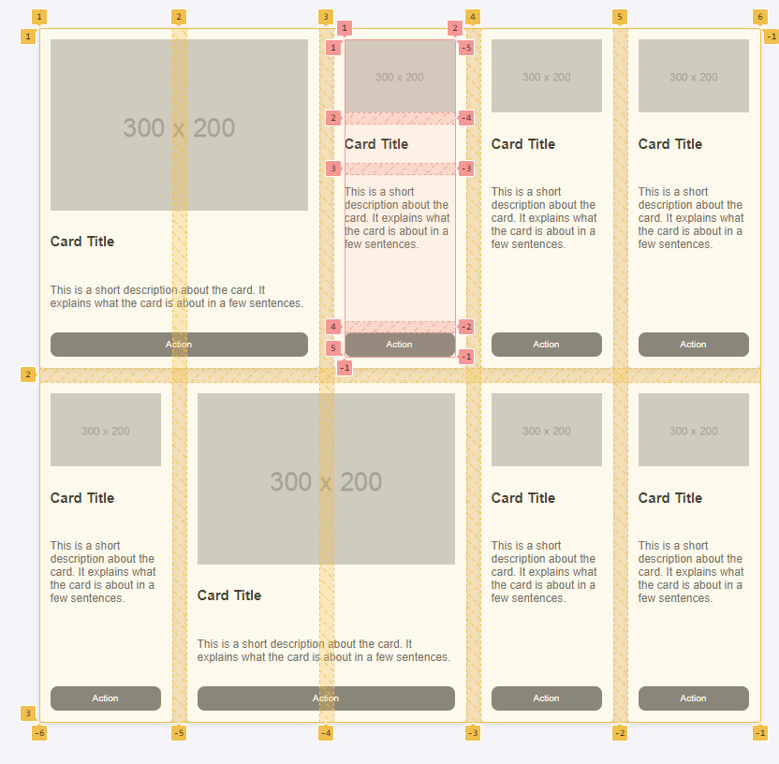

Notes
- Some cards span on 2 columns (class span2)
- Buttons should be vertically align with other button cards

EXERCISE 3: Responsiveness with grid layout
 Start code is provided for this exercise!

We want to add a bit of responsiveness to our page.
What is responsiveness and how to implement it with grid layout? Check out this link!
https://travishorn.com/responsive-grid-in-2-minutes-with-css-grid-layout-4842a41420fe

The layout should display a single-column card on small screens (mobile) and a multi-column card layout on larger screens (tablet/desktop).
- Phone (by default) 1 column of cards
- Tablets (> 601px): 2 columns of cards
- Extra-large screens (> 1024px): 3 columns of cards

TODO: Add the needed media queries to change the grid layout, according to the device

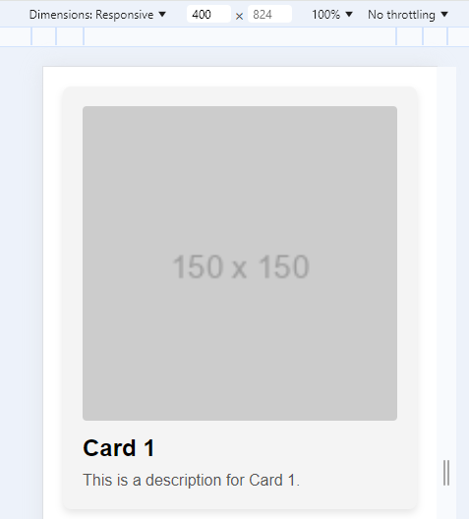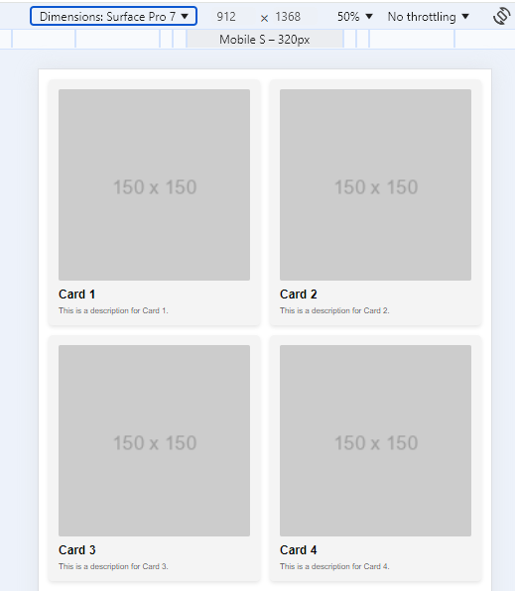
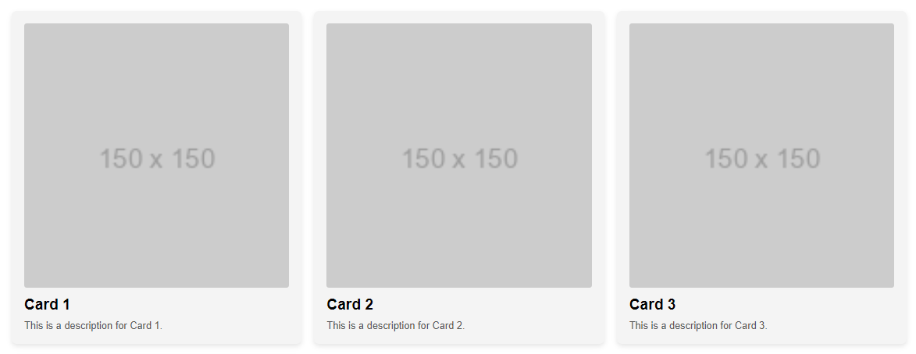

EXERCISE 4
Create a responsive dashboard layout using either CSS Flexbox or CSS Grid. The dashboard should be visually appealing and functional, adapting to various screen sizes.

This is a freestyle exercise, so you can express your creativity!!!

Note: we will ask you to explain your CSS strategy during the next review session. Be prepared to explain it.

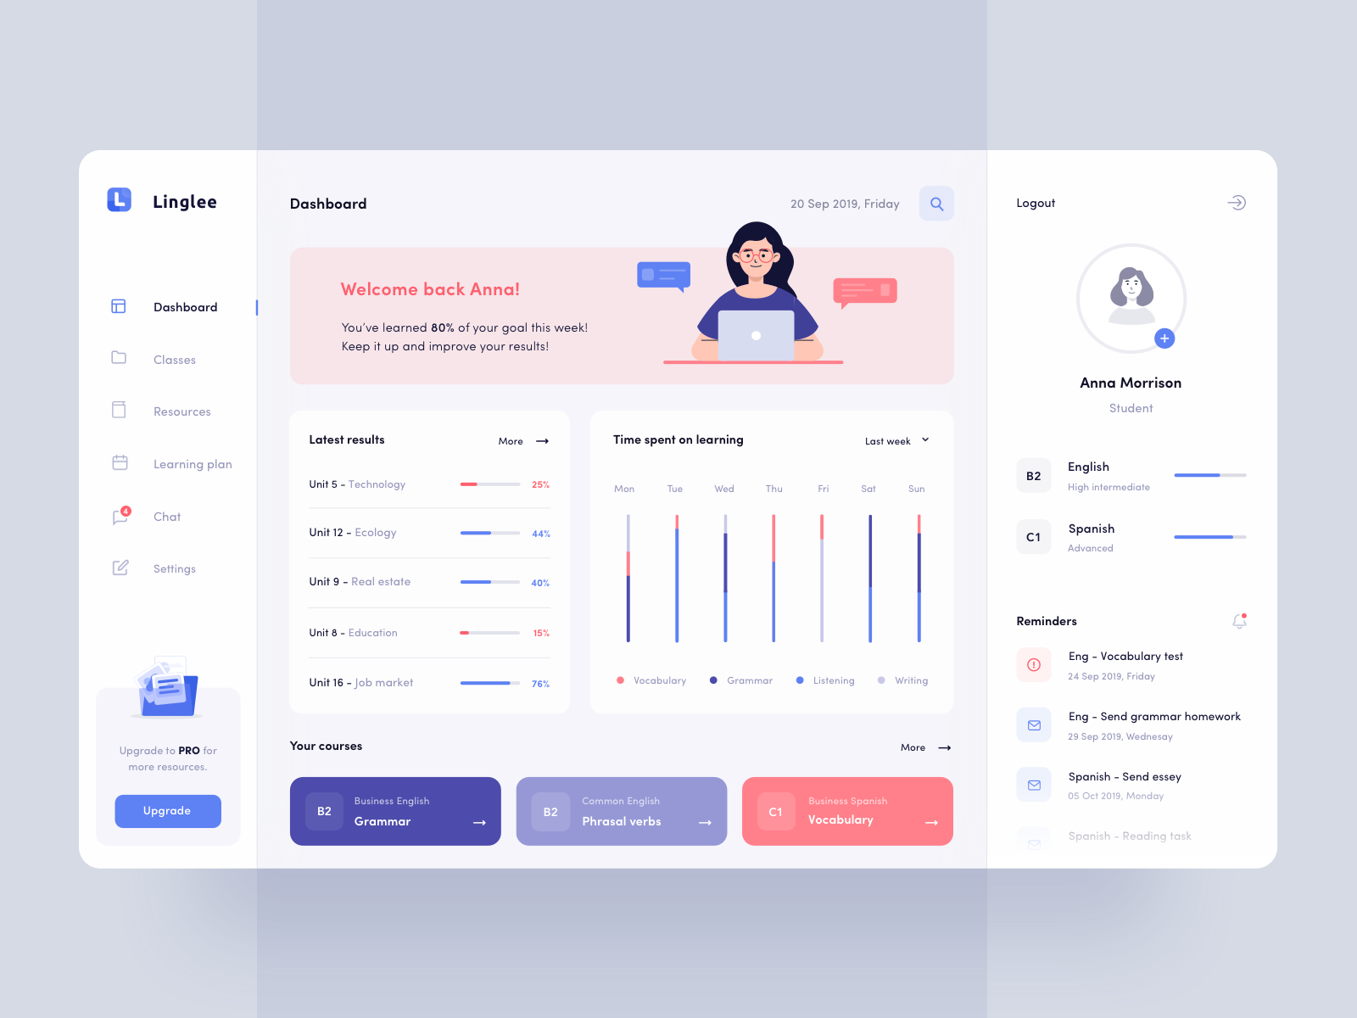
Example of dashboard

